ATLS 3519 Final Project | Peter Gailitis
  - Spohn Performance Website Redesign

Final Project Proposal

Site Selected and Description
Website URL: https://www.spohn.net/
The site I plan to redesign is the Spohn Performance website. Spohn Performance is a performance automotive parts manufacturer and online retailer that sells suspension, chassis, and drivetrain components for a wide range of vehicles, including GM, Ford, Ram, and Jeep models. The company was founded in 1999 and operates from Myerstown, Pennsylvania. The website includes a large product catalog, vehicle-specific categories, customer accounts, a shopping cart, support resources, customer vehicle galleries, videos, and company information. Although the site provides access to many specialized and useful products, its current presentation feels outdated and crowded. The large number of navigation choices, competing page elements, small text, and weak visual hierarchy make the site harder to scan and use than it needs to be.

Why I Chose This Site
I chose this site because I recently had to use it while rebuilding my grandfather’s 1988 Avanti, which had been sitting in a garage for approximately 25 years. Spohn Performance sells strong aftermarket parts that can be useful for a project like this, but the website makes finding and comparing those parts more difficult. I have encountered many poorly designed websites, and this one stood out since the quality of the products is better than the quality of the online shopping experience. A redesign would allow me to keep the company’s useful catalog while improving organization, readability, navigation, accessibility, and the overall appearance of the site. The project also has a personal connection because the vehicle restoration gave me a real reason to use the website rather than selecting a site only for the assignment.

Site Owner and Contact Status
Spohn Performance is owned and operated by Steven J. Spohn and is described as a family-run company. Steven J. Spohn is listed as the company president. I have attempted to make contact regarding a possible interview, but I have not received a response, so I am not currently expecting that an owner interview will be available for the project. I may still email the company a picture or mockup of the completed redesign and explain the main usability and accessibility improvements. I may also include a photograph of the finished Avanti restoration to show the real project that led me to their products and to request any feedback they are willing to provide.

Final Project First Draft
Website URL: https://www.spohn.net/

Brief Description of the Business
Spohn Performance is a family-operated performance automotive manufacturer and online retailer based in Myerstown, Pennsylvania. The company designs and sells suspension, chassis, and drivetrain components for muscle cars, trucks, Jeeps, street rods, and other performance vehicles. Its catalog is organized mainly by manufacturer, model generation, production years, and vehicle platform. The website also provides a support center, customer vehicle gallery, videos, company information, account tools, and online checkout. This is a specialized business whose customers may need to verify exact vehicle fitment before purchasing relatively expensive mechanical components. For that reason, the site must make product categories, compatibility, technical information, support, and purchasing steps especially clear. The current website contains useful products and a large amount of information, but much of that value is hidden by a crowded interface and an outdated browsing structure.

Planned Interviewees
The first planned interviewee is Steven J. Spohn or another Spohn Performance employee who understands the company’s products, customer questions, and current website. I have attempted to contact the company but have not received a response. I will document the contact attempt and use any response that arrives before the final deadline. If the owner is unavailable, I will try to contact a customer-service or technical-support representative instead.
The user interview will involve a person who has experience shopping for automotive repair or performance parts online. I will ask that person to locate a compatible suspension component, identify the relevant technical information, and explain what would make the site feel trustworthy and easy to purchase from. A second informal observation may involve a person who is unfamiliar with Spohn Performance so I can compare expert and first-time navigation. The interviews will focus on actual tasks and open-ended follow-up questions rather than only asking whether the participants like the visual design.

Project Goal
The goal is to redesign the Spohn Performance shopping experience so customers can quickly understand the company, select their vehicle, find compatible parts, compare products, and reach technical support. The redesign will preserve the company’s established products and automotive identity while replacing the crowded page structure with a clearer visual hierarchy and more predictable navigation. The proposed design will emphasize accessibility, responsive behavior, semantic HTML, and efficient product discovery.
- Create a simplified header with a prominent product search, account access, cart status, and support link.
- Add a clear “Shop by Year, Make, and Model” path so users do not have to remember platform names before browsing.
- Organize product categories into manageable menus instead of displaying the entire catalog hierarchy at once.
- Use a meaningful H1, logical headings, descriptive links, readable typography, and sufficient contrast.
- Redesign product cards so the image, product name, vehicle fitment, price, and primary action are grouped together.
- Provide complete keyboard access, visible focus indicators, useful alternative text, and properly labeled forms.
- Make technical support, compatibility guidance, shipping information, and return policies easy to locate before checkout.

Heuristic Evaluation of the Current Site
The current homepage was reviewed using common usability and accessibility heuristics. Severity is described as Major when the issue can prevent or strongly discourage task completion, Moderate when it creates delay or confusion, and Minor when it mainly affects polish or consistency. The evaluation includes strengths as well as problems that should guide the redesign.

WAVE Accessibility Evaluation Results
The WAVE evaluation yielded the following results for the current Spohn Performance homepage. These findings are incorporated into the heuristic evaluation below. Due to a formatting error I cannot figure out, the header below re-appears though it should not. A purposeful formatting technique used below was to shrink the size of certain text boxes’ text as to not have them run for multiple pages.
WAVE Category |  | Result from Current-Site Evaluation
Overall WAVE result |  | 40 errors, 32 contrast errors, 141 alerts, 26 features, 10 structural elements, and 5 ARIA items
AIM score |  | 2.3 out of 10
Linked images |  | 3 linked images missing alternative text
Forms |  | 1 missing form label
Document language |  | 1 missing or invalid language declaration
Links |  | 35 empty links
Heading structure |  | Only one heading was detected: H3 “Hot New Products”; no useful H1/H2 hierarchy was shown
Navigation order |  | The Order view shows a long sequence of header, account, search, catalog, product, and social links before and around the main content
Heuristic / Severity | Current-Site Finding | Necessary Correction
1. Clear page purpose and hierarchy — Major | The homepage opens with several utility areas, navigation rows, search controls, category links, and promotional graphics before presenting a clear page-level message. The company purpose is explained in body text, but there is no strong, prominent H1 that immediately identifies the page and its primary task. WAVE's Structure view detected only one heading on the page: an H3 labeled “Hot New Products,” with no meaningful H1 or H2 structure. | Add one descriptive H1 and a short value statement near the top, followed by logically nested H2 and H3 headings. Visually prioritize vehicle and product discovery over secondary promotions.
2. Information architecture — Major | A very long nested list of vehicle generations and product groups is exposed in the left column. Users must scan dozens of options, and the list mixes manufacturers, body platforms, date ranges, services, and replacement parts at the same level. | Use progressive disclosure: begin with vehicle make or a year/make/model selector, then reveal only relevant models and categories. Separate services and general parts from vehicle browsing.
3. Match with the user’s mental model — Major | The catalog relies heavily on terms such as F-Body, G-Body, A-Body, and platform-year combinations. Experienced customers may understand them, but a first-time owner may know only the vehicle year, make, and model. | Let users start with familiar vehicle information. Platform terminology can appear as supporting information after the vehicle is selected.
4. Recognition rather than recall — Major | Customers must remember which platform or generation matches their vehicle before selecting a category. The homepage does not provide obvious fitment guidance or a vehicle saved to the session. | Add a persistent vehicle selector, fitment confirmation, and a “My Vehicle” area. Show compatible categories after selection.
5. Navigation clarity — Moderate | The header contains a shipping message, brand area, live help, shop tour, cart controls, a long utility menu, account information, and search. These competing rows weaken the distinction between primary shopping navigation and secondary company links. | Use one compact utility bar and one primary navigation row. Group About, Customer Cars, Blog, and social content under secondary navigation or the footer.
6. Visibility of system status — Moderate | The cart item count and subtotal are visible, which is useful. However, search, chat availability, and category selection do not provide an equally clear sense of state from the homepage. | Keep the useful cart status. Add clear search result feedback, selected-vehicle status, loading indicators, and explicit online/offline chat status.
7. Search design — Major | The search area is visually small compared with the size of the catalog, and its wording combines “Search Products,” “Site,” and “Go” in a way that is less clear than a modern labeled search control. WAVE also reported one missing form label, indicating that at least one control does not have a properly associated accessible label. | Use a prominent search field with a persistent programmatically associated label, useful placeholder example, search button, spelling tolerance, and suggestions by product, vehicle, or part number.
8. Consistency and standards — Moderate | The page mixes image links, plain text links, utility controls, and category links with different visual treatments. Similar destinations are named differently in different areas, such as Contact versus Contact Us. WAVE also reported that the page language was missing or invalid, which can cause a screen reader to use the wrong pronunciation rules. | Standardize labels, button styles, link treatments, spacing, and naming. Use familiar shopping patterns for search, cart, filters, and product actions, and set a valid language attribute on the HTML element.
9. Aesthetic and minimalist design — Major | Many elements compete for attention at the same time: the complete category tree, newsletter sign-up, review graphic, membership information, carousel, support and social graphics, and a large product list. This makes the page feel dense even though much of the content is useful. | Prioritize the most common tasks and move secondary material lower on the page. Replace multiple promotional graphics with a focused introduction, key categories, and selected products.
10. Readability and scanning — Major | The design uses dense link lists, long product names, small supporting text, and limited spacing. Important information is difficult to distinguish quickly, especially for users with low vision, attention limitations, or a small display. WAVE identified 32 contrast errors across the evaluated homepage. | Increase base font size, line height, spacing, and heading contrast. Break long names into product name, fitment, and feature lines. Maintain readable line lengths and verify that text and interface controls meet WCAG contrast requirements.
11. Link purpose — Moderate | The homepage repeats vague link treatments and includes many linked graphics. WAVE reported 35 empty links, meaning those links do not provide an accessible name or readable purpose to a screen-reader user. | Remove links that have no destination or content. Give every remaining link a descriptive accessible name, such as “View tubular rear control arms,” and make the descriptive product title the primary link.
12. Images and alternative text — Moderate | Product and promotional images are heavily used throughout the page. WAVE reported three linked images missing alternative text, so a screen reader may announce only an unlabeled link or file information instead of the destination or image purpose. | Write concise alternative text for informative graphics, use empty alt text for decorative images, and give every linked image an accessible name that describes its destination.
13. Keyboard and screen-reader efficiency — Major | The exposed catalog and utility areas create a very long sequence of links and controls before and around the main product content. WAVE's Order view confirms a lengthy navigation sequence, while the overall report found 40 errors, 141 alerts, only 10 identified structural elements, and 5 ARIA items. Even when controls are technically reachable, empty links and weak headings make keyboard and screen-reader navigation inefficient. | Add a working skip link, semantic header, nav, main, and footer landmarks, collapsible accessible menus, logical headings, and a concise default navigation state. Remove empty links and test focus order, accessible names, and visible focus throughout.
14. Product presentation and comparison — Moderate | Hot products are presented with long titles, images, and repeated calls to action, but important shopping details such as price, fitment summary, key differences, and availability are not emphasized together on the homepage. | Use consistent product cards that group name, vehicle compatibility, price, stock status, rating if available, and one clear action. Add filters and comparison tools on listing pages.
15. Error prevention and recovery — Moderate | Because compatibility depends on precise vehicle information, selecting the wrong category can lead to an incorrect and costly purchase. The homepage provides categories but no obvious confirmation that a part fits the user’s vehicle. | Require or encourage vehicle selection, display a clear fitment confirmation, warn when fitment is uncertain, and provide helpful recovery paths instead of generic error messages.
16. Help and documentation — Minor/Moderate | The site provides a Support Center, FAQs, live help, phone assistance, and a shop tour, which are valuable strengths. However, these resources are distributed across several areas and may not appear at the point where a customer has a fitment question. | Keep these support options but consolidate them under a clear Help area. Place contextual fitment and installation help beside relevant products and checkout steps.
17. User control and freedom — Moderate | The number of categories and promotional destinations can pull users away from the shopping task. The homepage does not provide an obvious way to save a vehicle, recently viewed product, or comparison state and return later. | Support breadcrumbs, recently viewed products, saved vehicles, wish lists, and clear back/cancel actions without losing the user’s place.
18. Responsive and touch use — Moderate | The desktop homepage contains multiple horizontal header rows and a long sidebar. Simply stacking these elements on a smaller screen would create excessive scrolling and small touch targets. | Design mobile navigation intentionally, use large touch targets, collapse secondary links, keep search and cart easy to reach, and test the layout at common breakpoints.
Wireframe of the Current Home Page
Website URL: https://www.spohn.net/
The following low-fidelity wireframe was created digitally from the current desktop homepage. It records the existing content hierarchy and layout rather than showing the planned redesign.
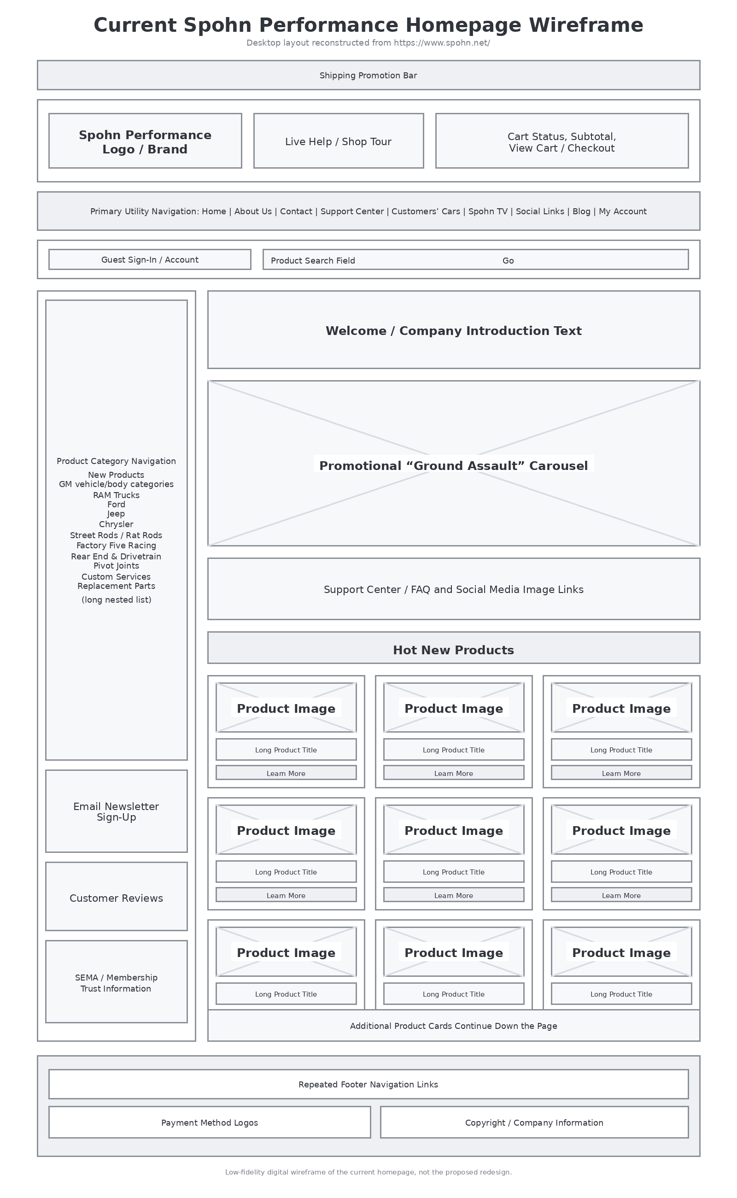
Figure 1. Current Spohn Performance homepage wireframe.

Site Map of the Current Site
Website URL: https://www.spohn.net/
Site Map URL: https://www.gloomaps.com/tqCtTWY7JG (Automatically updates throughout the project)
The following visual site map records the current Spohn Performance website structure. It is limited as per Part 1 instructions. Product model-year pages and individual articles continue beyond the depth shown here and will be completed for the final submission.
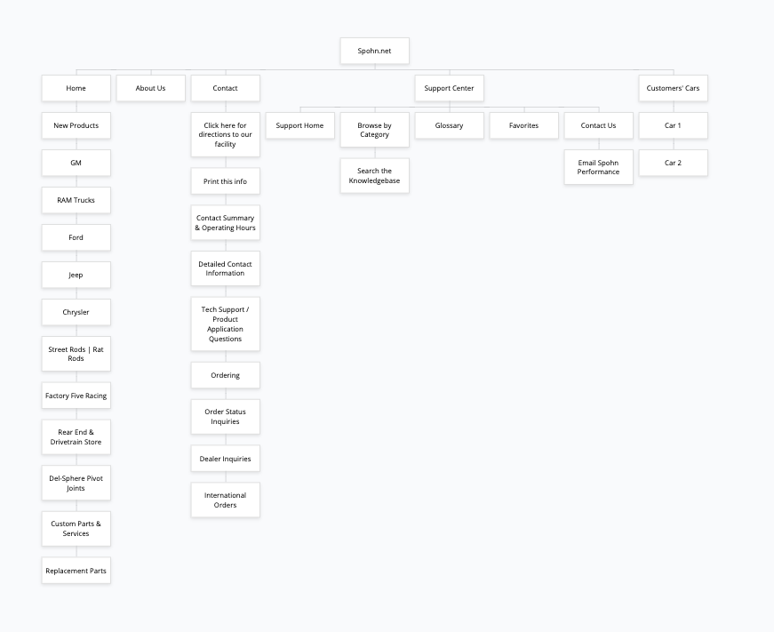
Figure 2. Current Spohn Performance website site map.

Final Project Second Draft
Website URL: https://www.spohn.net/

Updates from the First Draft
The proposal and first-draft sections above remain unchanged. This second draft adds a proposed information architecture, three wireframes for the redesigned site, two persona profiles with justification, and two coded prototype pages. The new design responds to the earlier heuristic and WAVE findings by reducing the number of competing navigation choices, giving vehicle selection and product search priority, establishing a useful heading hierarchy, consolidating support information, and using labeled controls, semantic page regions, descriptive links, visible keyboard focus, and responsive layouts. One of the only vehicles added is a 1988 Avanti, which is purposeful as I’m planning on adding in my own images for the final draft.

Please see GitHub repository for HTML and CSS files.
GitHub Repo: https://github.com/obsanity-live/ATLS3519-640F/tree/main/final_project_part2

Site Map of the Redesigned Site
Website URL: https://www.spohn.net/
The proposed site map limits the home page to five primary branches and shows the redesigned structure up to three levels down. (per instructions) The structure gives product discovery the strongest position while keeping technical help, company information, community content, and account functions available without exposing the entire catalog at once. A different site was used for this sitemap, though I may revert to the last format for the final draft.
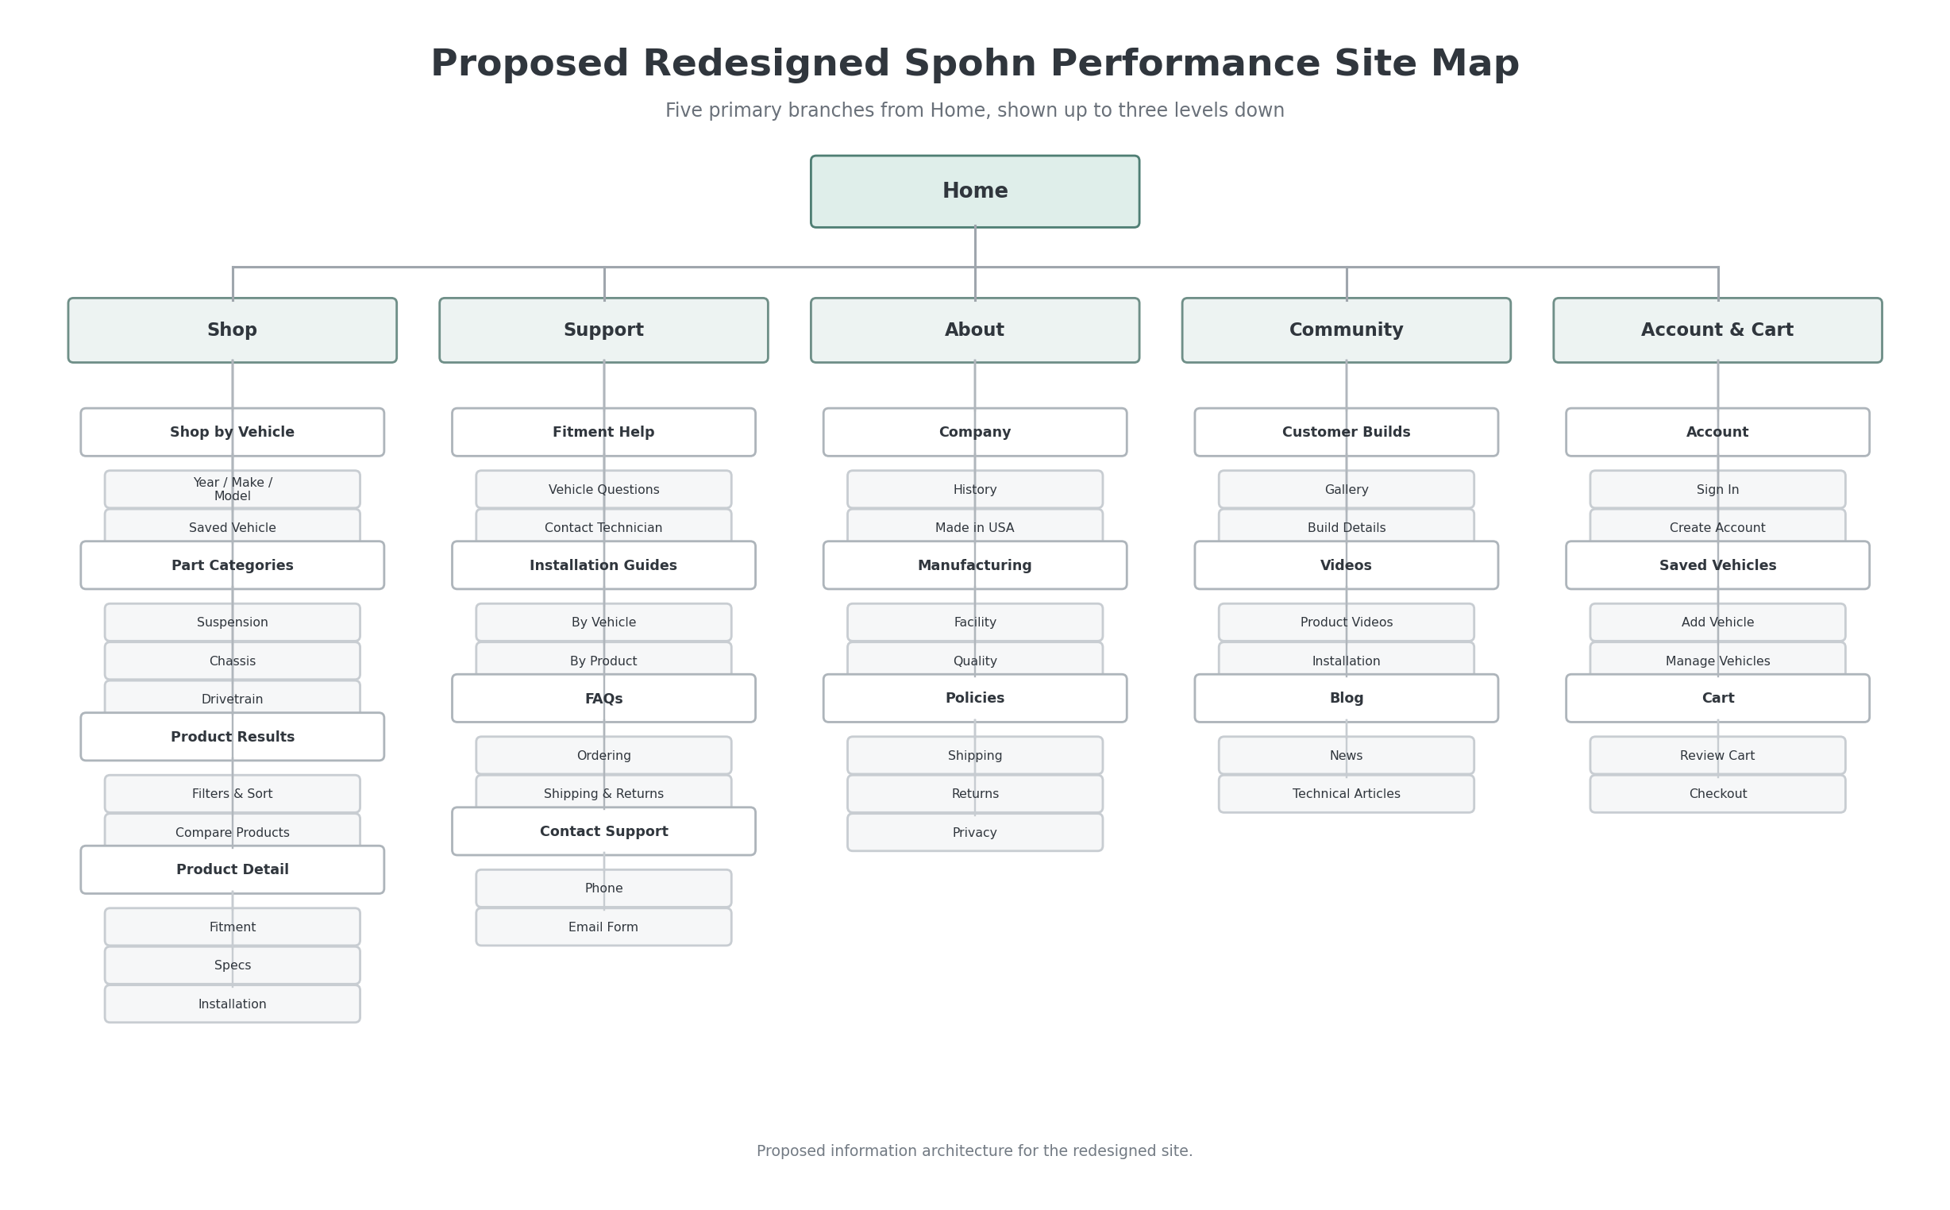
Figure 3. Proposed site map for the redesigned Spohn Performance website.

Wireframes of the Redesigned Site
The following low-fidelity wireframes show the redesigned home page and two subpages. They preserve the company’s automotive identity while reorganizing content around vehicle fitment, product discovery, readable information, and accessible interaction.

Redesigned Home Page
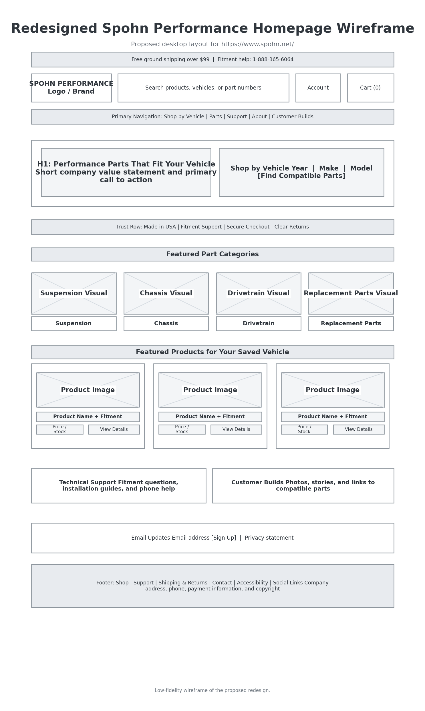
Figure 4. Proposed redesigned home page wireframe.

Redesigned Product Results Page

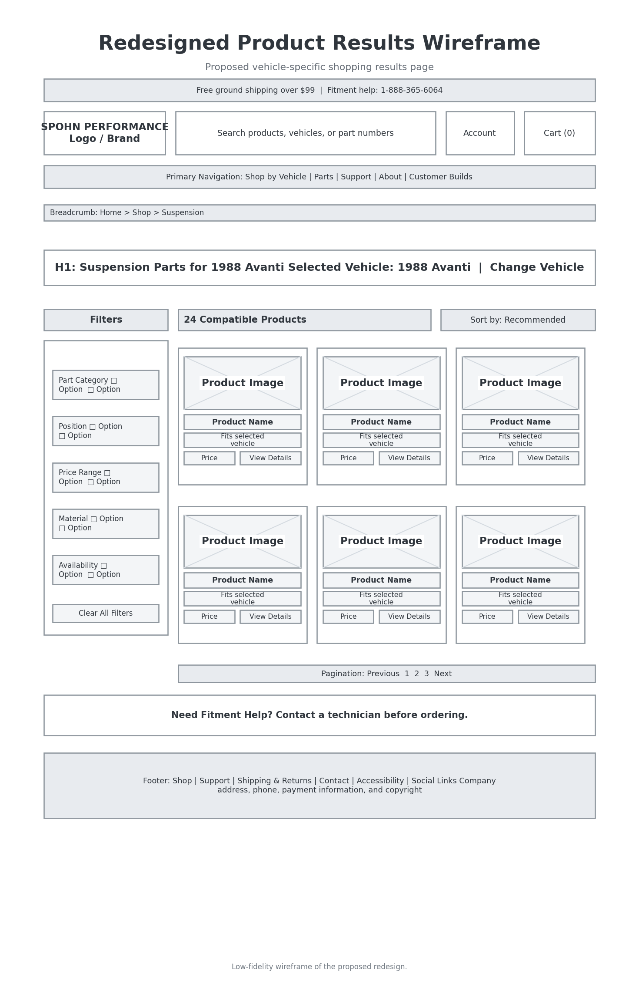
Figure 5. Proposed vehicle-specific product results wireframe.

Redesigned Product Detail Page
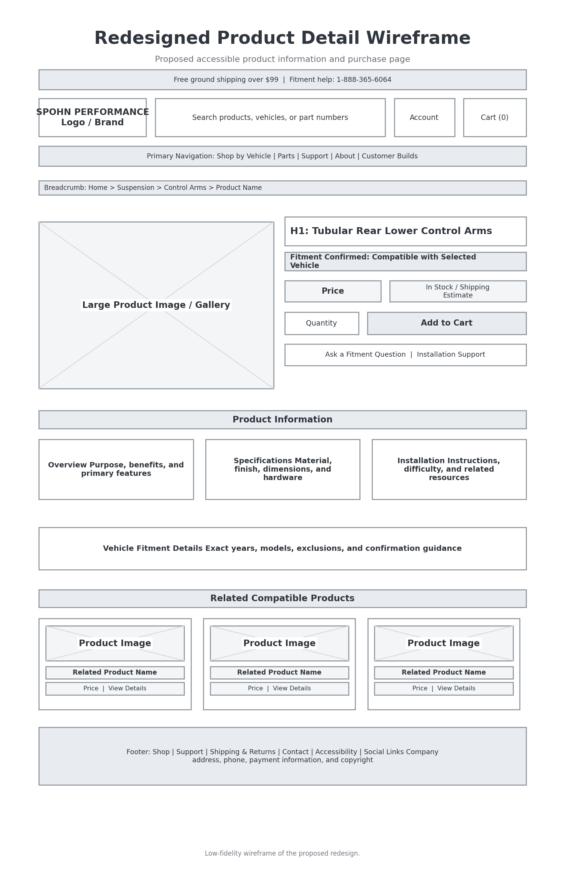
Figure 6. Proposed product detail page wireframe.

Persona Profiles
The personas below represent two different but important users of the redesigned site. They are fictional profiles based on the site’s shopping tasks, the earlier heuristic evaluation, and common needs involved in purchasing vehicle-specific performance parts.

Persona 1: Michael Reyes - Experienced Restorer
Profile Area | Persona Details
Background | Michael is 58 and has restored and modified vehicles for more than twenty years. He is comfortable with mechanical terminology and usually shops from a desktop computer in his garage or home office.
Primary goals | Confirm exact compatibility, compare materials and adjustment ranges, review installation requirements, and order the correct part without having to call unless the fitment is unusual.
Behaviors | Searches by year, make, and model; checks technical specifications; opens installation instructions before purchasing; and compares several products in separate tabs.
Frustrations | Long category trees, repeated promotional graphics, missing prices, unclear stock information, and product titles that do not clearly separate the part name from fitment details.
Design needs | A persistent saved vehicle, detailed specifications, compatibility confirmation, downloadable instructions, breadcrumbs, and direct access to a knowledgeable technician.

Persona 2: Jordan Lee - First-Time Performance Parts Buyer
Profile Area | Persona Details
Background | Jordan is 26 and recently purchased a used truck. Jordan understands the vehicle’s year, make, and model but is unfamiliar with platform codes and many suspension terms. Jordan often browses on a phone and uses browser zoom because small text is difficult to read.
Primary goals | Understand which upgrade solves the handling problem, identify parts that definitely fit, see the total cost, and feel confident about shipping, returns, and installation difficulty.
Behaviors | Begins with a general search, reads category explanations, relies on product photos and short summaries, and looks for reviews or support before placing an expensive order.
Frustrations | Small text, weak contrast, unexplained platform names, dense pages, controls that are difficult to tap, vague links, and forms that do not keep labels visible after typing.
Design needs | Plain-language category descriptions, responsive layouts, large touch targets, visible labels, readable contrast, clear fitment status, concise product cards, and easy access to return and support information.

Justification for the Personas
Michael and Jordan were selected because the redesign must support both experienced automotive customers and people who do not know platform codes or specialized terminology. Michael tests whether the site provides the depth, precision, and efficient comparison tools needed for a costly technical purchase. Jordan tests whether the same catalog remains understandable, readable, and usable on a smaller screen. Together, the personas justify the year/make/model selector, persistent fitment status, layered technical information, accessible forms, responsive navigation, larger controls, clear support paths, and consistent product cards.

Coded Prototype Pages
Two pages of the redesigned site were coded in HTML and share one external CSS file. The prototype uses semantic HTML, a skip link, labeled search and vehicle forms, a logical heading order, descriptive links, keyboard focus indicators, responsive layouts, and product information grouped in consistent cards. The files can be uploaded together to the same web directory.
File | Page | Implemented Features
index.html | Redesigned home page | Header and search, primary navigation, year/make/model selector, category cards, featured products, support section, email form, and footer.
products.html | Redesigned product results page | Breadcrumbs, selected-vehicle status, labeled filters, sorting, compatible product cards, pagination, and technical-support callout.
style.css | Shared visual and responsive design | Readable typography, strong contrast, visible focus, responsive grids, large controls, consistent cards, and mobile breakpoints.
Prototype note: The coded product names, compatibility statements, and prices are illustrative course content rather than current Spohn Performance listings. In other words, some stuff is there as filler-text until I refine my final draft.

Once again, the GitHub Repo Link:
https://github.com/obsanity-live/ATLS3519-640F/tree/main/final_project_part2

